Reset Waste Ink Counter (Clearing Waste Ink Absorber Full Error) for Group B
August 10th, 2008 by admin

Related models:
canon i250,255,320,350,355
canon pixma ip1000,1200,1300,1500,1600,1700,1800,1880,2200,2580 etc.
Hi everybody! In the previous post I have told you how to reset waste ink counter for group A. Now I will explain how to fix Waste Ink Absorber Error for printer categorized in Group B (see also ..). One of type of this group is ip1000. Well, here is the procedure.
To reset waste ink counter for group B, perform the following step:
- Enter service mode.
- Connect USB cable (you may also connect USB cable before entering service mode, no problem).
- Run General Tool for each series from your computer; select below procedure which appropriate with your printer model.
For i320/xnu i320
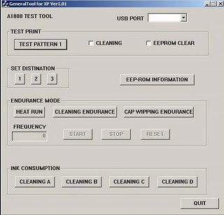
- Select USB port
- In destination set: choose 1 for xnu i320, or choose 2 for i320.
- Exit general tool and run your printer as usual.
For i250 series (255/350/355), ip1000,ip1500
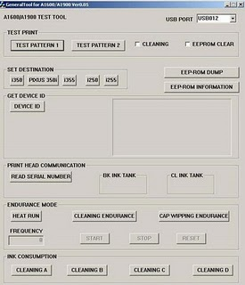
- Select USB port
- Mark EEPROM clear check box.
- Click Test Pattern button, wait until a pattern completely printed.
- Exit general tool and run your printer as usual.
Note: ip1000 & have the same procedure with i255 series.
For ip1200 series (1200/1600/2200), ip13000 series (1300/1700), ip1880
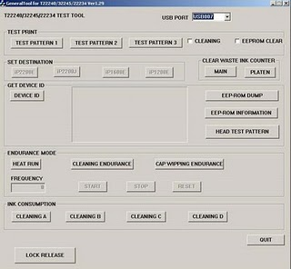
- Select USB port
- Click waste ink counter: Main & Platen
- Exit general tool and run your printer as usual.
If you dont’t have EEPROM resetter (general tool) yet, you can follow the link provided in this blog.
Related posts:
Entering Service Mode
Reset Waste Ink Counter for Group A
Reset Waste Ink Counter without Replacing Absober

