1. 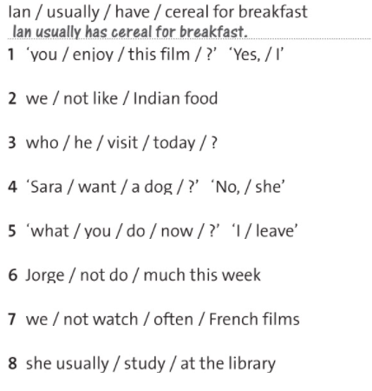Present Simple or Present Continuous
2. …………………………….………………………………..……
3. …………………………….………………………………………
4. …………………………………….………………………………
5. ……………………………………………………………………
6. ……………………………………….……………………………
7. ……………………………………………….……………………
8. ……………………………………………………….……………
9. ……………………………………………………………….……

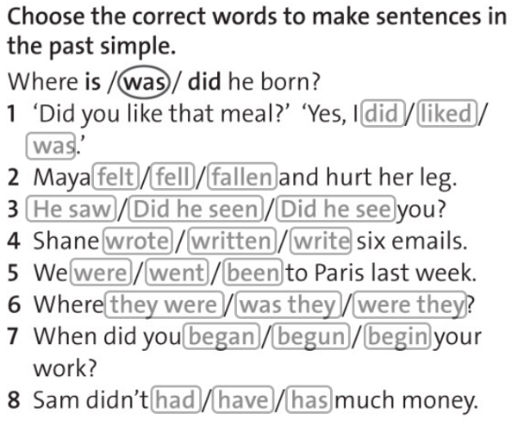

**3 Write questions /6**

Julie loves ice cream.

S: ……………………………………………………………………….

O: ………………………………………………………………………

The tiger ate the monkey.

S: …………………………………………………………………..….

O: …………………………………………………………….…….…

Peter is reading a book.

S: ………………………………….……………………………………

O: ………………………………….…………………………………..

1. Present Simple or Present Continuous
2. .…………………………….……………………………..……
3. ………………………….………………………………………
4. ………………………………….………………………………
5. ……………………………………………………………………
6. ……………………………………….……………………………
7. ……………………………………………….……………………
8. ……………………………………………………….……………
9. ……………………………………………………………….……



**3 Write questions /6**

Julie loves ice cream.

S: ……………………………………………………………………….

O: ………………………………………………………………………

The tiger ate the monkey.

S: …………………………………………………………………..….

O: …………………………………………………………….…….…

Peter is reading a book.

S: ………………………………….……………………………………

O: ………………………………….…………………………………..