Your name: ________________________________________

**(11 pont)**

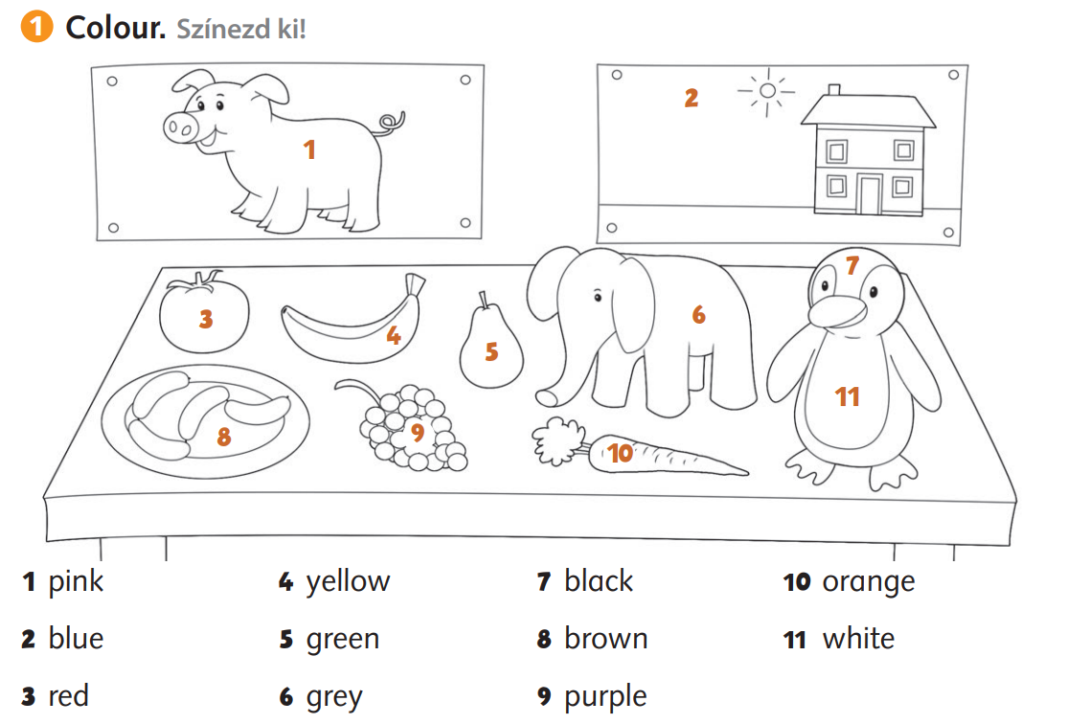

2. **Complete with the following words.** Egészítsd ki a következő szavakkal:

*boat house flowers fish birds*  **(5 pont)**

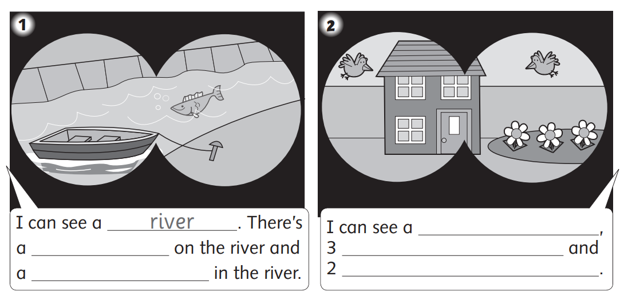

**3. Draw! Rajzolj! (14 pont)**

|  |  |  |
| --- | --- | --- |
| a book | a butterfly | seven apples |
| five oranges | a cake | eight bees |
| ten balls | two girls | the sun |