**Your name: ………………………………………..**

1. **Choose the best option /12**

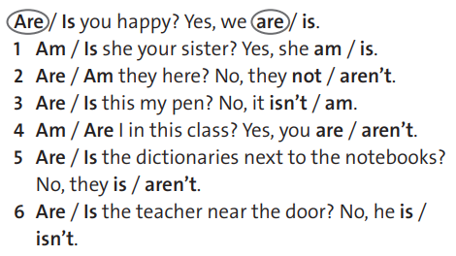

1. **Connect the opposites /6**

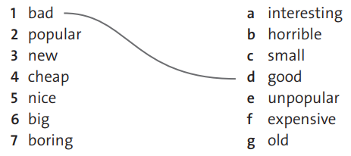

1. **Match the animals with the pictures /9**

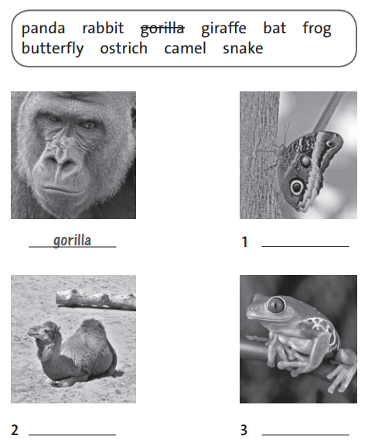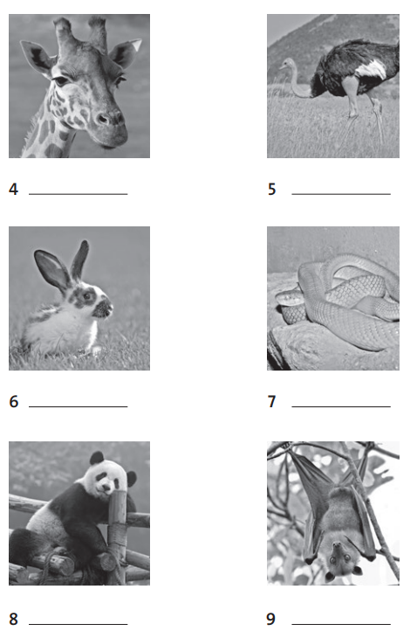

1. **Make words /6**

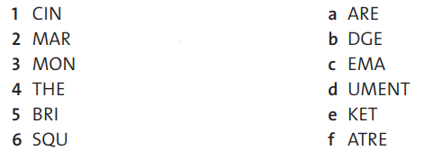…………………………………….

…………………………………….

…………………………………….

…………………………………….

…………………………………….

…………………………………….

1. **Choose the correct words /6**

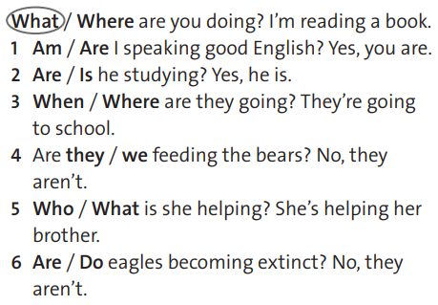

1. **Match the words with the pictures /8**

