**Your name: _____________________________**

1. **Look and write /6**

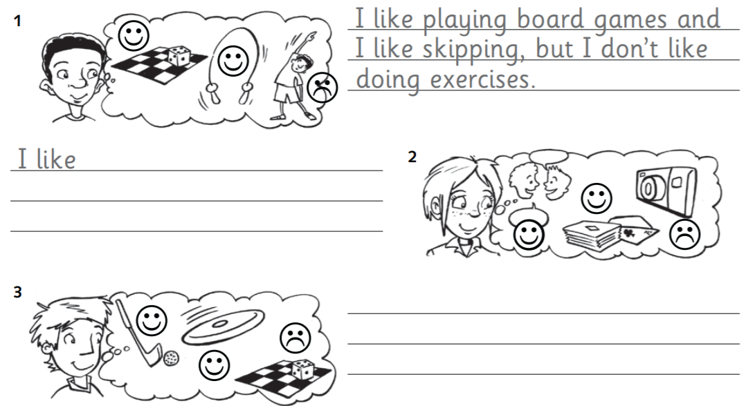

1. **Read and answer /5**

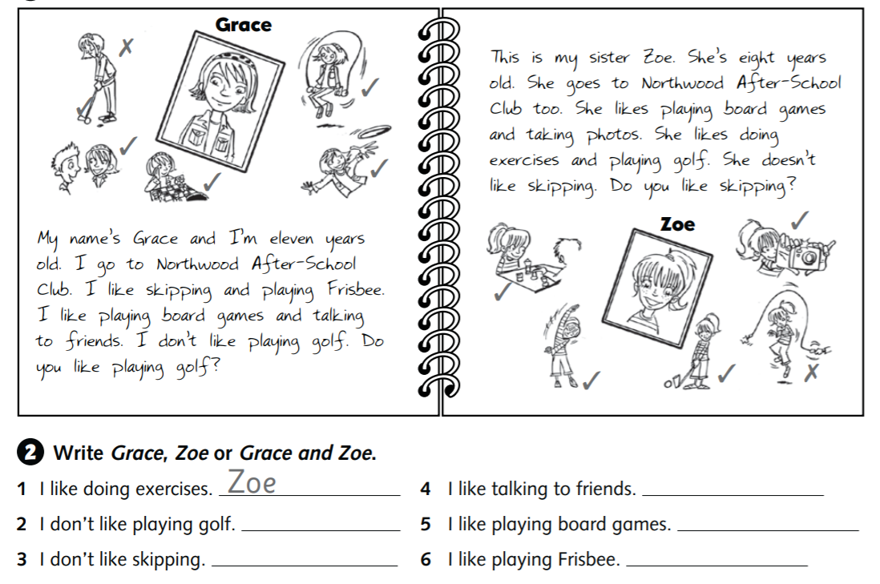

1. **Answer the questions /9**

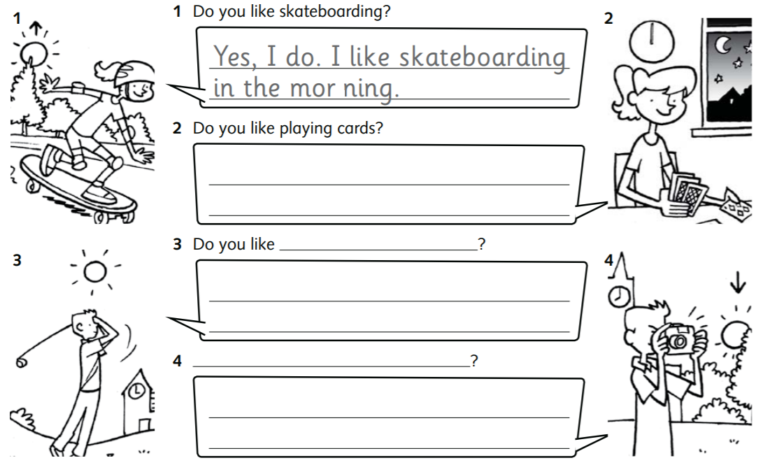

1. Can you remember? ☺

