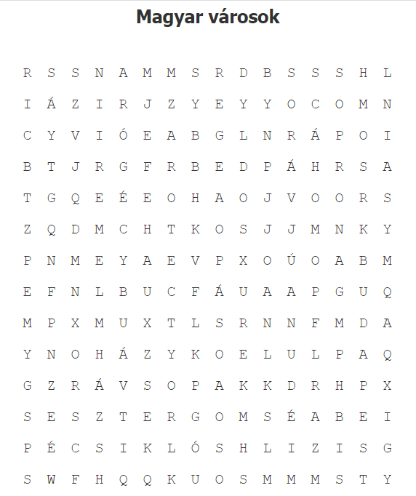

**Mit találtál? Mit tudsz róla**?

1. _________________________________________________
2. _________________________________________________
3. _________________________________________________
4. _________________________________________________
5. _________________________________________________
6. _________________________________________________
7. _________________________________________________
8. _________________________________________________
9. _________________________________________________
10. _________________________________________________
11. _________________________________________________
12. _________________________________________________
13. _________________________________________________
14. _________________________________________________
15. _________________________________________________
16. _________________________________________________
17. _________________________________________________
18. _________________________________________________
19. ________________________________________________
20. _________________________________________________

