Tuesday, February 05, 2008

Printer Canon i320 Service Manual
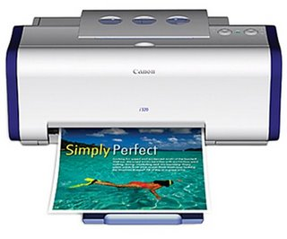The Bubble Jet i320 not only gives photo quality output on all media with its 2400x1200dpi resolution and advanced MicroFine Droplet Technology? but it also prints at up to 10ppm in mono and up to 7ppm in colour.
Table Of Contents
- Product List
- Product Specification
- Error Display
- Service Mode
- External View/Parts
- Troubleshooting Flowchart
- Service Information
And for reset this printer you can find here
Download Canon i320 Printer Service Manual
Password : printer1.blogspot.com

http://rs331.rapidshare.com/files/112059955/CANON_i320_SM.rar

