

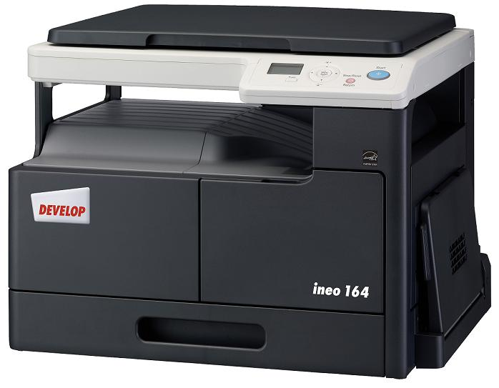

ineo 164
Product Guide
15.02.11
Table of contents

Product Basic 3
Product Configuration 4
System Specifications 6
Copier Specifications 7
Printer Specifications (GDI) 9
Scanner Specifications 10
Consumables 11
Article Numbers and Compatibility 12
Service Part 13
Appendix 14

Product Basic
MODEL DEVELOPMENT CODE | Pegasus L
PROPOSED MODEL NAME | ineo 164
SUCCESSOR MODEL FOR | new
ESTIMATED SALES START | 06/10
DATAQUEST SEGMENT | I
ALSO AVAILABLE AS | KM bizhub 164
TYPE | Desktop/Stationary Platen
MAX. (PEAK) MONTHLY PAGE VOLUME | 12.0 k copies
MAX. AVERAGE/PERMANENT MONTHLY PAGE VOLUME | 2.8 k copies
MACHINE LIFE | 168 k copies or 5 years, which ever comes first  Scanner durability 100 k pages
MCBF Body  (Mean Copies Between Failure) | 23 k copies
MCBJ (Mean Copies Between Jam) | 2 k copies or more
MCBV (Mean Copies between Visit) | no data
MTTR (Mean Time To Repair) | Less than 30 min.
OPERATING CONDITIONS | 2 pages/job, 6 % coverage
SAFETY & ENVIRONMENT
English/German Data Sheets | Downloadable in the dBox

Standard paper weight for systems is 80 g/m² for monochrome machines and 90 g/m² for full colour ones. Since using these standards
result in optimum system performance, all specifications on performance, reliability, maintenance and replacement based on those stan-
dard papers. Using thick papers, labels, transfer and polyester films continuously can increase the wear and tear on replacement parts
and consumables – meaning your servicing costs will go up.
Use the bypass or the lower tray from the paper feed unit when working with materials having such characteristics as polyester films,
textile transfer films and labels. Otherwise, you may be faced with double feeding or a higher number of feeding jams.
If possible use subtray when working with materials having such characteristics as polyester films, textile transfer films and labels. Roller-
marks on the copy or print may appear or increased jams can occur. Standard paper weights yield the best possible copy and print results.
Using higher grammage may influence the quality of the output. Using standard paper weights also guarantees that double sided copies
and prints are made reliably. Different characters of films as well as thick, thin and coated papers may increase the jam rate for double
sided copies and prints.

Product Configuration

SYSTEM DIMENSIONS
ineo 164

ineo 164 + MB-503
Unit: mm (Inch)

SYSTEM CONFIGURATION
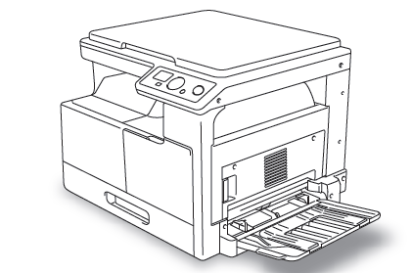
Standard
- 250 sheet Universal Cassette Tray
- Original Cover

Option

- 100 sheet Multi Bypass Tray MB-503
- USB Device Server

System Specifications
UNIVERSAL CASSETTE TRAY | Standard
Capacity | 250 sheets universal (80 g/m²)
Paper Format | A5 – A3  (CD: 90 to 297 mm/FD: 140 to 432 mm)
Paper Weight | Plain Paper: 64 – 90 g/m²  Thick Paper: 91 – 157 g/m²
Max. Paper Capacity | 350 sheets (Universal Cassette Tray + Multi Bypass Tray)
Remark | OHP, postcards , envelopes and labels are not supported
MULTI BYPASS TRAY MB-503 | Option
Capacity | 100 sheets universal (80 g/m²)
Paper Format | A5 – A3  (CD: 90 to 297 mm/FD: 140 to 432 mm)
Paper Weight | Plain Paper: 64 – 90 g/m²  Thick Paper: 91 – 157 g/m²
Remark | OHP, postcards , envelopes and labels are not supported
USB DEVICE SERVER | Option
Remark | For network printing/scanning

Copier Specifications
 | ineo 164
WARM-UP TIME Main Power ON | 29 sec. or less
Sub Power ON | No Sub Power Switch
FIRST COPY | 8 sec. or less (A4)
COPY SPEED
Plain Paper | 16 cpm (A4 crosswise)  9.1 cpm (A3)
Thick Paper | 7 cpm (A4 crosswise)  5.3 cpm (A3)
RESOLUTION  Reading/Writing | 600 x 600 dpi
GRADATION | 256
COPY RAM | 32 MB (standard & max.)
ZOOM | 50 % - 200 % adjustable in 1 % steps
MULTI COPY | 1 – 99
EXPOSURE CONTROL | Manual: 9 steps, Text, Photo, Photo/Text,  Auto: Text, Text/Photo
VOID AREA | 4 mm all edges
INNER OUTPUT TRAY CAPACITY | 250 sheets
POWER REQUIREMENT | 220 – 240 V : 3.5 A, 50 – 60 Hz
POWER CONSUMPTION | Max.:800 W  Copying: 253 W  Stand by: 70 W  Sleep mode: 1.8 W
COPIER DIMENSIONS (W x D x H) mm | Standard: 570 x 531 x 449  Incl. MBT: 606 x 531 x 449
COPIER WEIGHT (kg) | 23.5 (w/o Toner & Developer)

FEATURES
2in1/4in1 | yes
Copy Function Memory | yes (2)
Power Save | yes (sleep mode & stand by)
Book Separation | yes
ID Copy | yes
Sort/Group | yes
Electronic Sort | yes
Criss/Cross Sort | yes with optional MB-503
Paper Type Selection | Plain / Thick1 / Thick 2 / Recycled

Printer Specifications (GDI)
TYPE / VERSION | GDI Controller
PRINT SPEED
 | 16 ppm A4 crosswise / 9.1 ppm A3 / 7 ppm A4 thick paper
PRINT RESOLUTION | 600 x 600dpi
MAX PRINTABLE AREA | 294 x 420 mm minus 4 mm on all edges
PRINT RAM | 32 MB (shared system memory)
HOST INTERFACE | USB 1.1, USB 2.0
SUPPORTED OS
Server | Windows 2000 / 2003 Server / 2008 Server  Windows 2003 Server x 64 Edition
Client | Windows 2000 / XP / Vista / Windows7  Windows XP / Vista / Windows7 x64 Edition

Scanner Specifications
SCAN FUNCTIONS
Selection of Original Image Quality | Text / Photo
Scan Speed | Flatbed Scan only
Scan Size | Max. A3
Interface | USB 1.1, USB 2.0 equivalent
Supported OS | Windows 2000 / XP / Vista / Windows7 / 2003 Server / 2008 Server
Driver | TWAIN Driver
Scan Function | TWAIN
 | Real Time Mode (Pull)
Application Software | TWAIN Driver only
SCAN UNIT
Scan Method | CIS (7488 pixels)
Light Source | LED

Consumables
TONER for ineo 164
Name | TN116
Concept | Bottle
Weight | 500 g (281.5 g Toner) per bottle
Yield | 11.0 k copies / prints (6% coverage) per bottle
Type | HD polymerized Toner
Units per carton | 2 bottles
DEVELOPER for ineo 164
Name | DV116
Weight | 200 g
Yield | 55 k copies / prints
Units per carton | 1 bag
PC-DRUM for ineo 164
Name | DR114
Yield | 55 k copies / prints
Units per carton | 1 drum

Important: The yield values listed in the above table indicate the average life time of the Developer, Drum and
Toner. The life time is very much depending on printing conditions (coverage, paper size, etc.), differences
in the printing method (continuous or one page printing) and type of media (plain paper, thick paper, films, etc.).

Article Numbers and Compatibility
MACHINE | Article Number
ineo 164 (230V Version) | A0XX121
ineo 164 (120V Version) | A0XX1P1
ACCESSORIES | Article Number | Compatibility
Multi Bypass Tray MB-503 | A1XRWY1 | ---
USB Device Server | 9960ASX1000U | ---
CONSUMABLES
Toner TN116 | A1UC0D0 | ---
Developer DV116 | A1UC5D0 | ---
PC Drum DR114 | 4021029801 | ineo 161/210, ineo 163/213

Service Part
Maintenance and Firmware Upgrade

Please refer to the related Service Manual.

Notebook recommendation for Service support (minimum configuration)

Hardware:
Notebook, 2GB RAM, 250GB HDD (at least 30 GBs free HDD space when fully configured),
Optical Drive (CD/DVD Read & Write), PCMCIA Slot, 10/100Mbit Ethernet, USB 2.0

Software:
WinXP (rather than Vista or Windosw 7), MS-Office, Acrobat Reader, Burning Software (Nero Suite,
IBM Record Now etc.), FTP Client (Filezilla etc.)

Periodical Replacement Parts
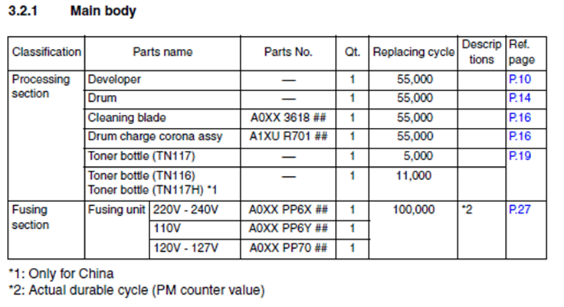

Appendix
Productivity Chart (Simplex 1:1)
Size | Universal Cassette Tray |  | Multi Bypass | Thick Paper Mode
A3 | 9.1 |  | 9.1 | 5.3
B4 | 10.3 |  | 10.3 | 5.7
A4 L | 12.2 |  | 12.2 | 6.3
A4 C | 16.0 |  | 16.0 | 7.0
A5 L | 16.0 |  | 16.0 | 7.0
A5 C | 20.4 |  | 20.4 | 8.0
First Copy Time
Size |  | Time (sec. or less)
A3 |  | 10.8
B4 |  | 10.0
A4 L |  | 9.3
A4 C |  | 8.0
A5 L |  | 8.0

What is delivered with the machine?
Parts | Packed in Japan | Added in Europe
Toner | no | ---
PC-Drum | yes | ---
Developer | yes | ---
Feeder | N/A | ---
Original Cover | yes (standard) | ---
Copy Tray | incorporated | ---
Printed LRI incl. DVD with Driver & User’s Guide | --- | yes
Face Sheets | N/A | N/A

www.develop.eu

Note!
Since changes in technical features are
the order of the day in the world of
digital copiers and printing technology,
please note that the technical data
provided in this material was issued in
April 2010. We reserve the right to
make changes to the technical design.
Specifications refer to maximum
performance under standard conditions.
No guarantee is provided in
relation to any of the data supplied.

Your Develop Marketing

