1 Correct the mistakes in bold in the sentences.

1 How long have you been **lived** in this house? __________

2 Mr Davis has been our science teacher **since** two years. __________

3 I can’t find my notebook. Have you **seeing** it? __________

4 I **didn’t** met the new student yet. __________

5 I’ve been studying English **for** I was eleven years old. __________

2 Choose the correct options.

1 Have you ____ this film before?

**a** seen **b** been seeing **c** saw

2 The match ____ finished.

**a** didn’t **b** hasn’t **c** hasn’t been

3 I’ve been ____ this game for an hour. I need a break!

**a** played **b** play **c** playing

4 You ____ made some mistakes in your essay.

**a** have been **b** did **c** have

5 Have you ____ for a long time?

**a** wait **b** been waiting **c** waiting

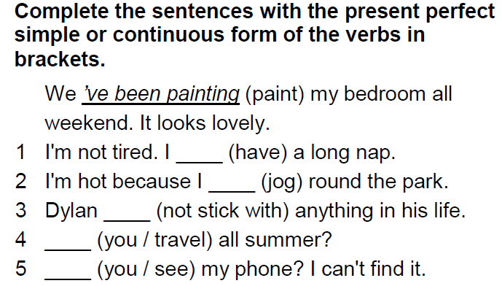**3**

1 Correct the mistakes in bold in the sentences.

1 How long have you been **lived** in this house? __________

2 Mr Davis has been our science teacher **since** two years. __________

3 I can’t find my notebook. Have you **seeing** it? __________

4 I **didn’t** met the new student yet. __________

5 I’ve been studying English **for** I was eleven years old. __________

2 Choose the correct options.

1 Have you ____ this film before?

**a** seen **b** been seeing **c** saw

2 The match ____ finished.

**a** didn’t **b** hasn’t **c** hasn’t been

3 I’ve been ____ this game for an hour. I need a break!

**a** played **b** play **c** playing

4 You ____ made some mistakes in your essay.

**a** have been **b** did **c** have

5 Have you ____ for a long time?

**a** wait **b** been waiting **c** waiting

**3**