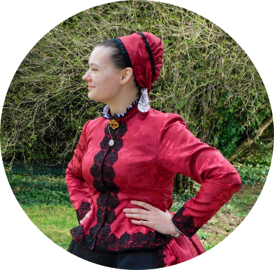  Summary  Researcher of Swabian folk costumes (Ungarndeutsche Volkstrachten) in Baranya county. Enthusiastic about preserving Swabian culture, alongside teaching (and doing) folk dance.  Relevant skills  People skills:  Communication  Leadership  Management  Critical thinking  Conflict resolution  Computer skills:  Spreadsheets  Presentation softwares  Word processors  (Social media)  Language skills:  Hungarian – native  English – advanced  German – intermediate  Spanish – elementary  Swedish – elementary  Slovak – beginner | Johanna Tengler  Researcher | folk enthusiast and dancer  Professional experience  Mcc Kp Research Scholarship Programme • 2023 – present  My research work is assisted and financed by the above programme, in which I am working together with a professional mentor, who assists and guides me in writing my disquisition in my chosen field and theme.  Wakaner NNHE Tanzverein• 2023 – present  Szársomlyó Nép-táncz egyesület • 2021 – present  Pelikán kulturális – és Táncegyesület • 2021 – present  Ratzpeterer NNHE Kultur– und tanzverein• 2020 – 2023  The above mentioned dance groups and organizations provide most of my experience: I have previously been and am currently an active member of several formations.  Education  Kanizsai Dorottya primary school, siklós, 2012-2020  Ciszterci rend nagy lajos gimnáziuma és kollégiuma, Pécs, 2020-2024  Specialised in Ethnology, took a course in Ethnocreology.  Matura exams:  Geography (84%)  Advanced English (98%)  Contact  E-mail: tengler.johanna@diak.crnl.hu  Mobile: 06 20 573 3161  LinkedIn: www.linkedin.com/in/johanna-tengler-5b05a12a2

